FABRIC STANFORD_HEALTHCARE_ANALYTICS_PROJECT

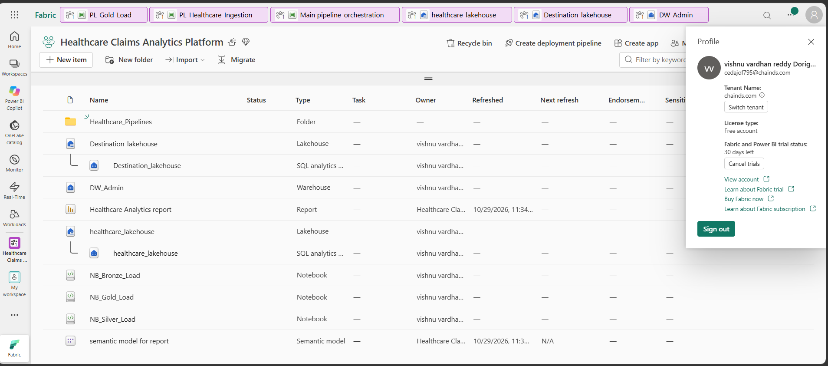
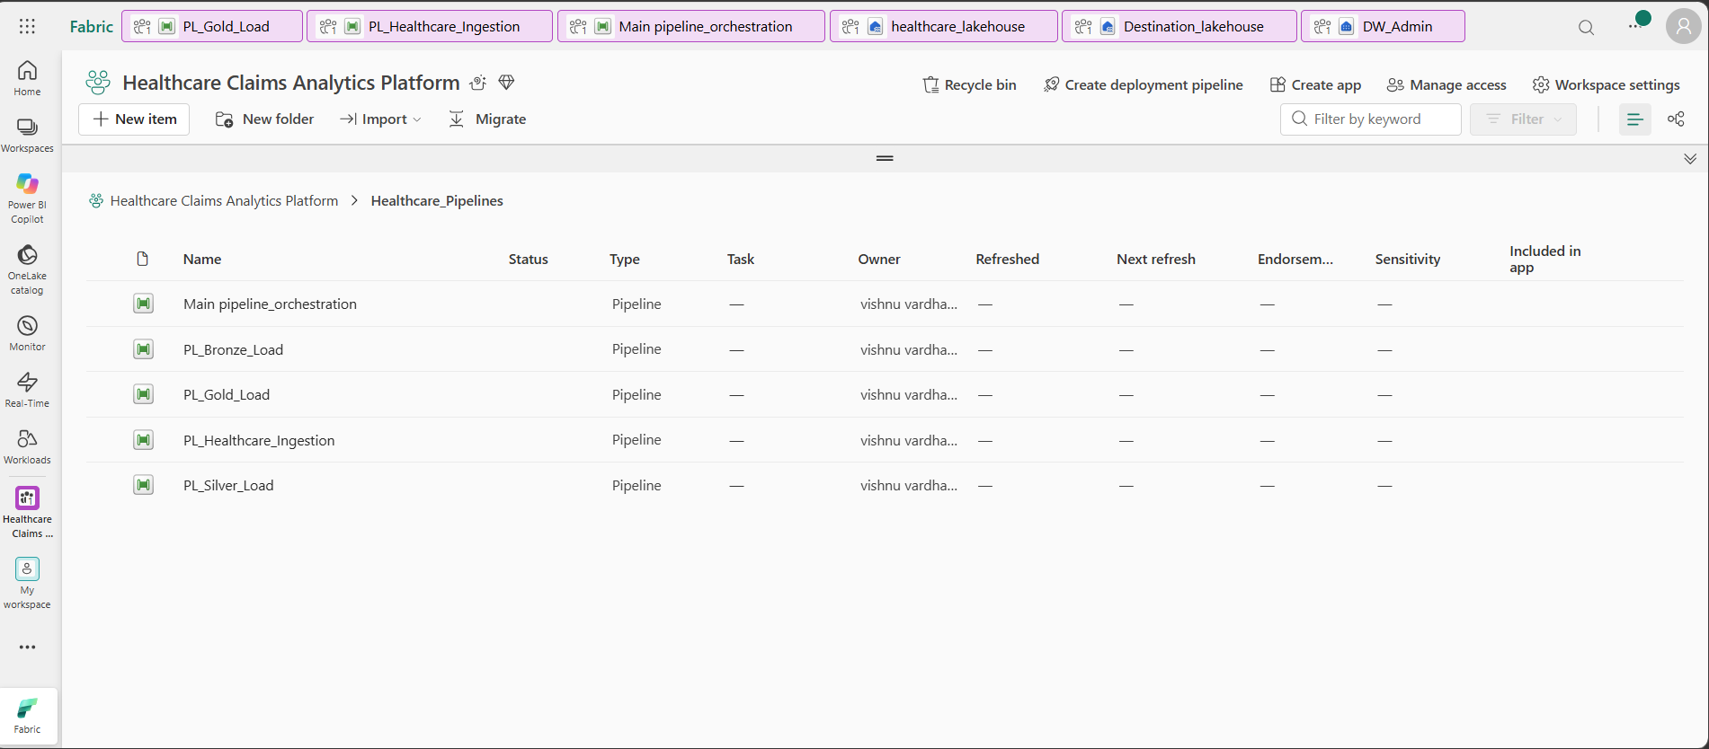

Process:
For this project we created sources
1.fabric lakehouse
2.github
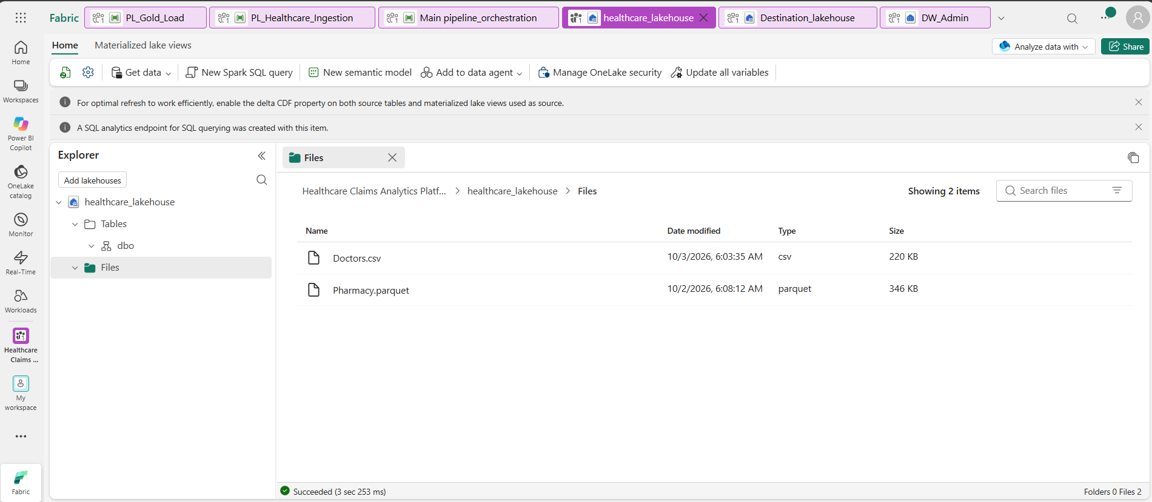
In github we have three files:
1.claims.json
2.Hospitals.csv
3.patients.csv

Here main thing we need to load all at once not use copy activity again and again we need to build metadriven table in sql warehouse.
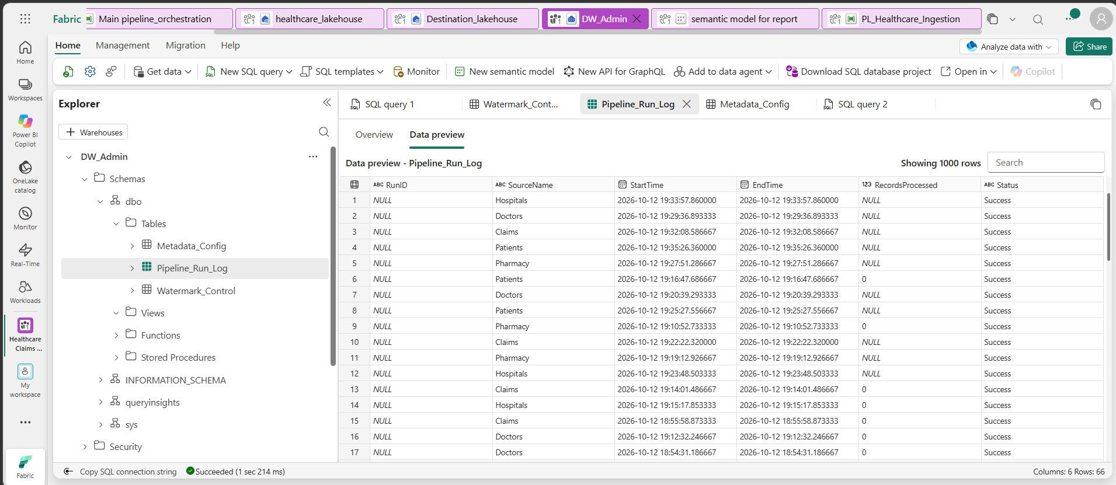
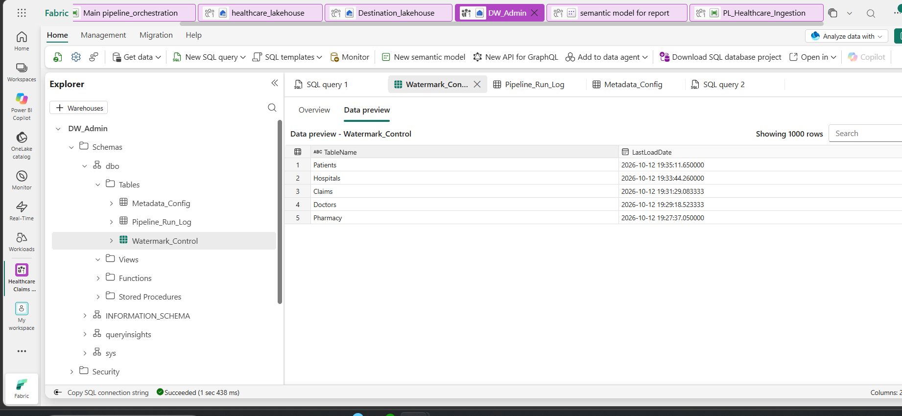
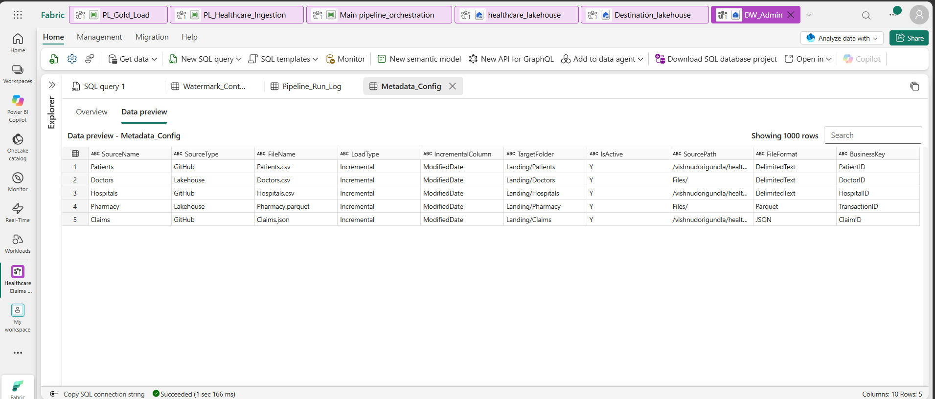
Sql query:
CREATE TABLE Watermark_Control
(
TableName VARCHAR(100),
LastLoadDate DATETIME2(6)
);CREATE TABLE Pipeline_Run_Log
(
RunID VARCHAR(100),
SourceName VARCHAR(100),
StartTime DATETIME2(6),
EndTime DATETIME2(6),
RecordsProcessed INT,
Status VARCHAR(50)
);
INSERT INTO Watermark_Control
VALUES
('Patients','1900-01-01'),
('Hospitals','1900-01-01'),
('Pharmacy','1900-01-01'),
('Doctors','1900-01-01'),
('Claims','1900-01-01');
SELECT * FROM Watermark_Control;
SELECT * FROM Pipeline_Run_Log;

CREATE TABLE Metadata_Config
(
SourceName VARCHAR(100),
SourceType VARCHAR(50),
FileName VARCHAR(200),
LoadType VARCHAR(50),
IncrementalColumn VARCHAR(100),
TargetFolder VARCHAR(200),
IsActive CHAR(1)
);
INSERT INTO Metadata_Config
VALUES
('Patients','GitHub','Patients.csv',
'Incremental','ModifiedDate',
'Landing/Patients','Y'),

('Hospitals','GitHub','Hospitals.csv',
'Incremental','ModifiedDate',
'Landing/Hospitals','Y'),

('Pharmacy','GitHub','Pharmacy.json',
'Incremental','ModifiedDate',
'Landing/Pharmacy','Y'),

('Doctors','Lakehouse','Doctors.xlsx',
'Incremental','ModifiedDate',
'Landing/Doctors','Y'),

('Claims','Lakehouse','Claims.json',
'Incremental','ModifiedDate',
'Landing/Claims','Y');
SELECT * FROM Metadata_Config;
UPDATE Metadata_Config
SET FileName =
'https://raw.githubusercontent.com/vishnudorigundla/healthcare-files/main/Patients.csv'
WHERE SourceName='Patients';

UPDATE Metadata_Config
SET FileName =
'https://raw.githubusercontent.com/vishnudorigundla/healthcare-files/main/Hospitals.csv'
WHERE SourceName='Hospitals';

UPDATE Metadata_Config
SET FileName =
'https://raw.githubusercontent.com/vishnudorigundla/healthcare-files/main/Pharmacy.json'
WHERE SourceName='Pharmacy';
SELECT SourceName, FileName
FROM Metadata_Config;
ALTER TABLE Metadata_Config
ADD SourcePath VARCHAR(1000);
UPDATE Metadata_Config
SET SourcePath='https://raw.githubusercontent.com/vishnudorigundla/healthcare-files/main/'
WHERE SourceType='GitHub';
UPDATE Metadata_Config
SET SourcePath='Files/'
WHERE SourceType='Lakehouse';
UPDATE Metadata_Config
SET FileName = 'Patients.csv'
WHERE SourceName = 'Patients';

UPDATE Metadata_Config
SET FileName = 'Hospitals.csv'
WHERE SourceName = 'Hospitals';

UPDATE Metadata_Config
SET FileName = 'Pharmacy.json'
WHERE SourceName = 'Pharmacy';
select * from Metadata_Config;
ALTER TABLE Metadata_Config
ADD FileFormat VARCHAR(50);
UPDATE Metadata_Config
SET FileFormat='DelimitedText'
WHERE SourceName IN ('Patients','Hospitals');

UPDATE Metadata_Config
SET FileFormat='JSON'
WHERE SourceName='Claims';

UPDATE Metadata_Config
SET FileFormat='Excel'
WHERE SourceName='Doctors';

UPDATE Metadata_Config
SET FileFormat='Parquet'
WHERE SourceName='Pharmacy';
SELECT *
FROM Metadata_Config;
UPDATE Metadata_Config
SET FileName='Pharmacy.parquet'
WHERE SourceName='Pharmacy';
UPDATE Metadata_Config
SET SourceType='Lakehouse',
SourcePath='Files/'
WHERE SourceName='Pharmacy';
UPDATE Metadata_Config
SET SourceType = 'GitHub',
SourcePath = 'https://raw.githubusercontent.com/vishnudorigundla/healthcare-files/main/'
WHERE SourceName = 'Claims';
UPDATE Metadata_Config
SET SourcePath = '/vishnudorigundla/healthcare-files/main/'
WHERE SourceType = 'GitHub';
UPDATE Metadata_Config
SET FileName='Doctors.csv',
FileFormat='DelimitedText'
WHERE SourceName='Doctors';
ALTER TABLE Metadata_Config
ADD BusinessKey VARCHAR(100);
UPDATE Metadata_Config
SET BusinessKey='PatientID'
WHERE SourceName='Patients';

UPDATE Metadata_Config
SET BusinessKey='HospitalID'
WHERE SourceName='Hospitals';

UPDATE Metadata_Config
SET BusinessKey='ClaimID'
WHERE SourceName='Claims';

UPDATE Metadata_Config
SET BusinessKey='DoctorID'
WHERE SourceName='Doctors';

UPDATE Metadata_Config
SET BusinessKey='TransactionID'
WHERE SourceName='Pharmacy';

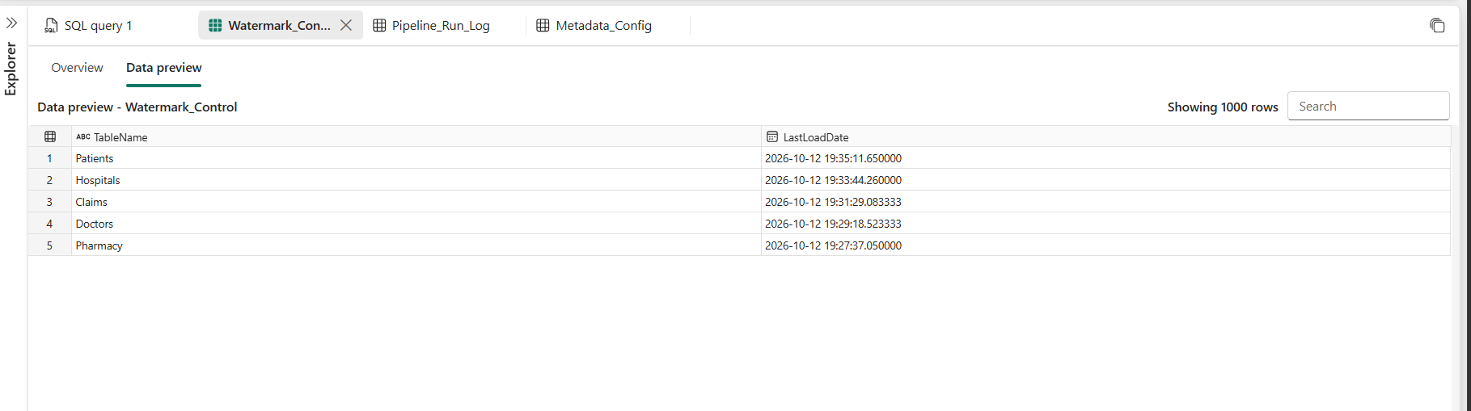
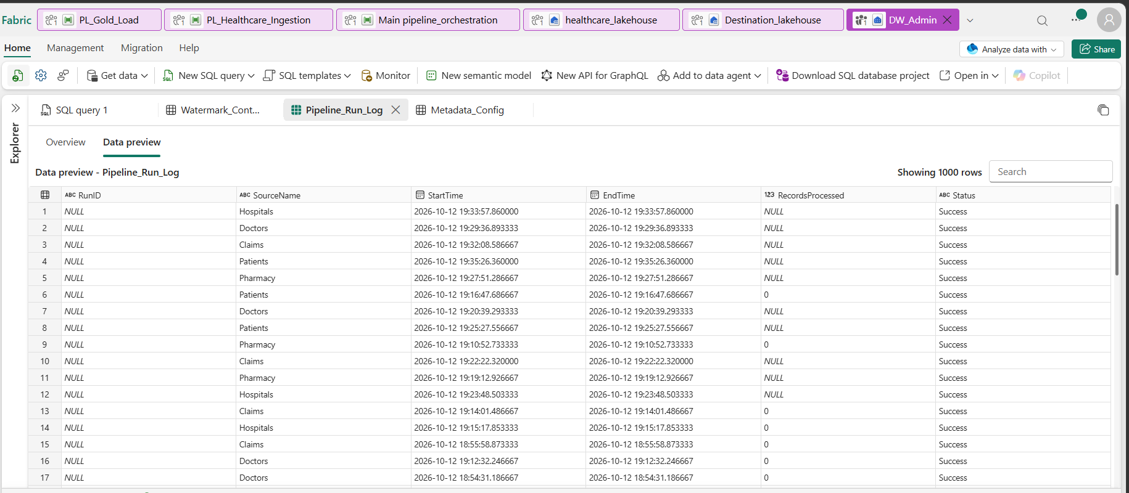

Pl_Ingestion:
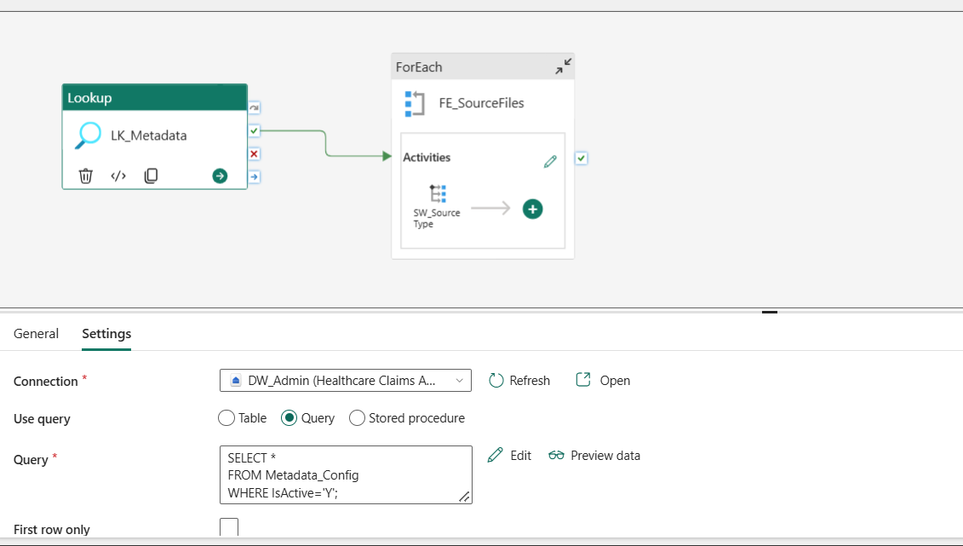
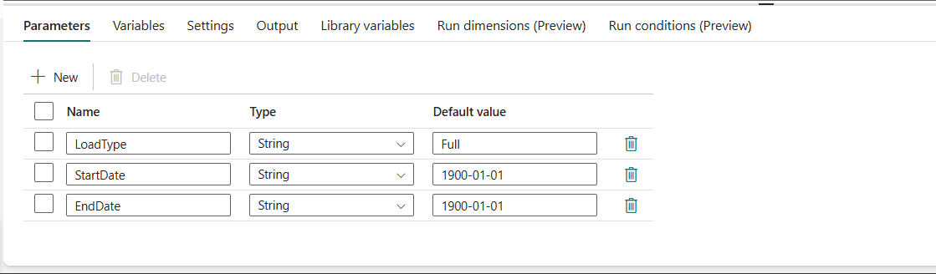
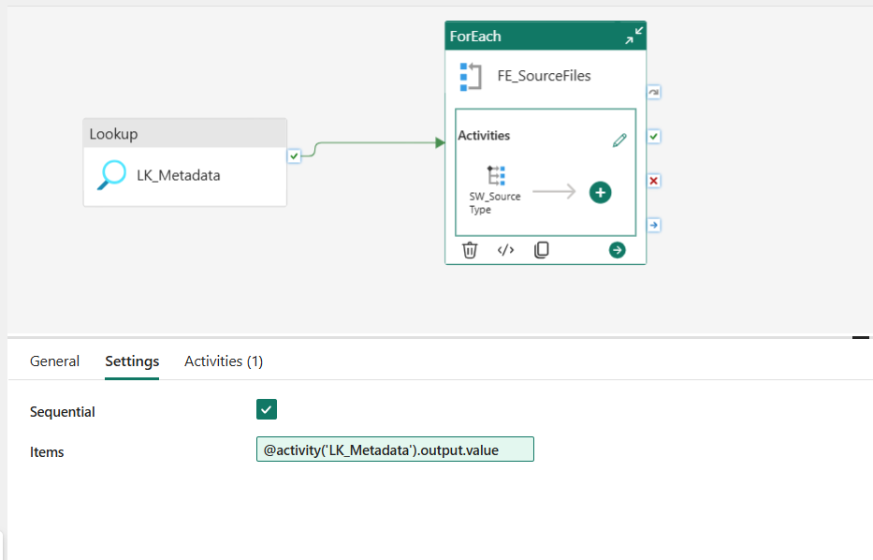
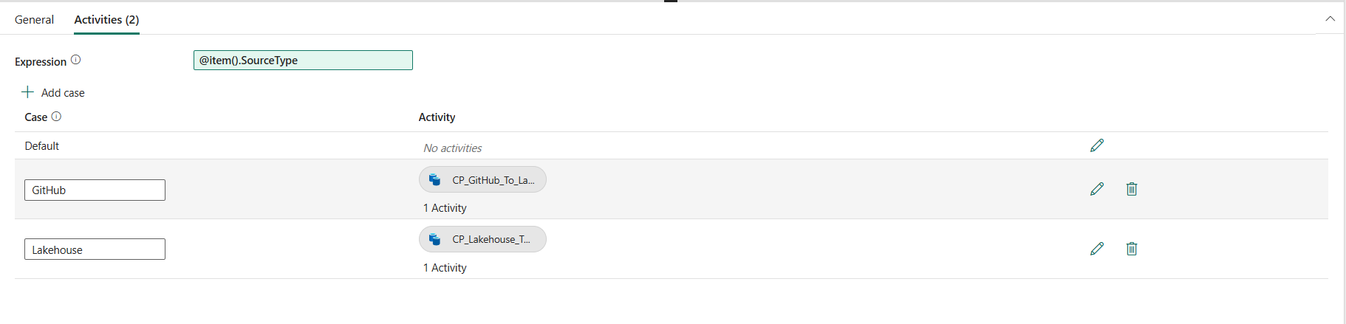
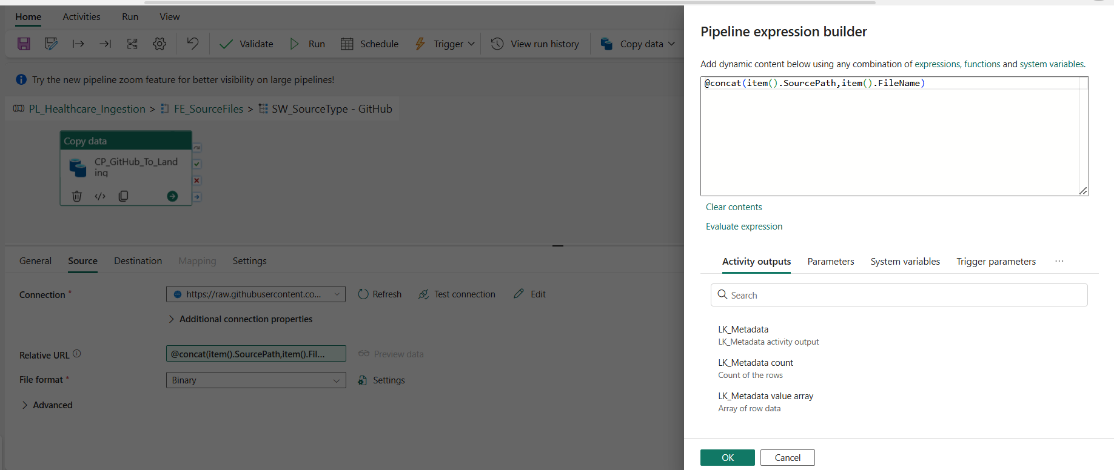

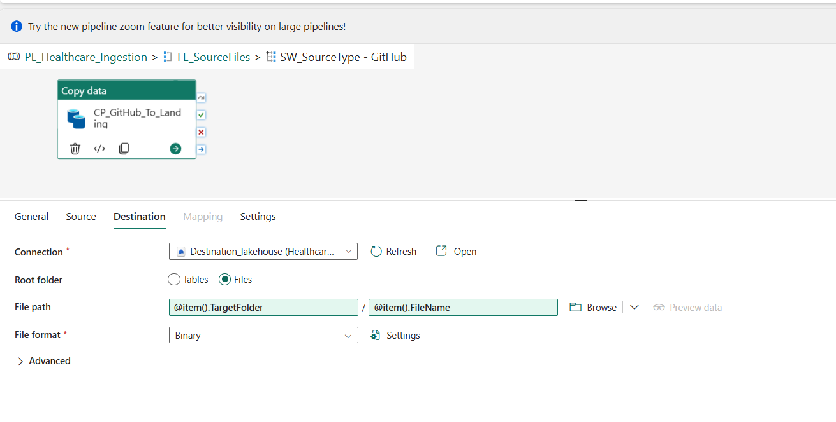

Pl_bronze:
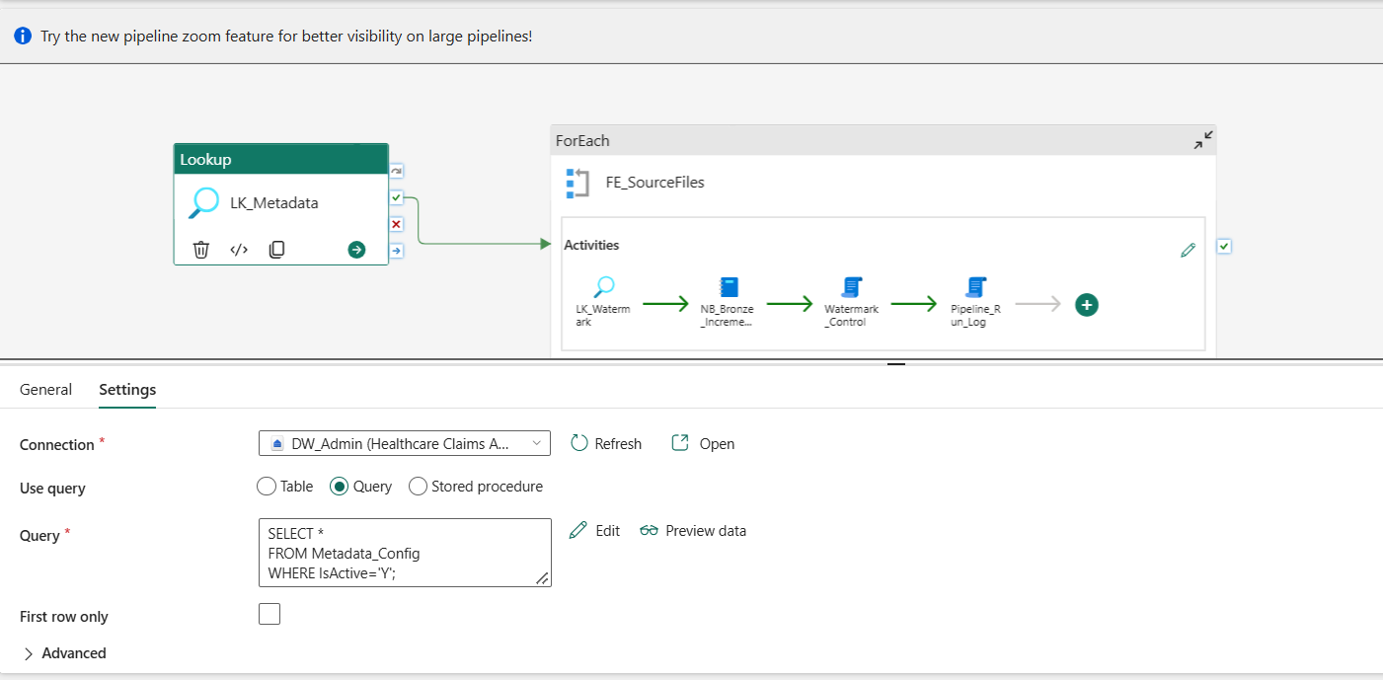
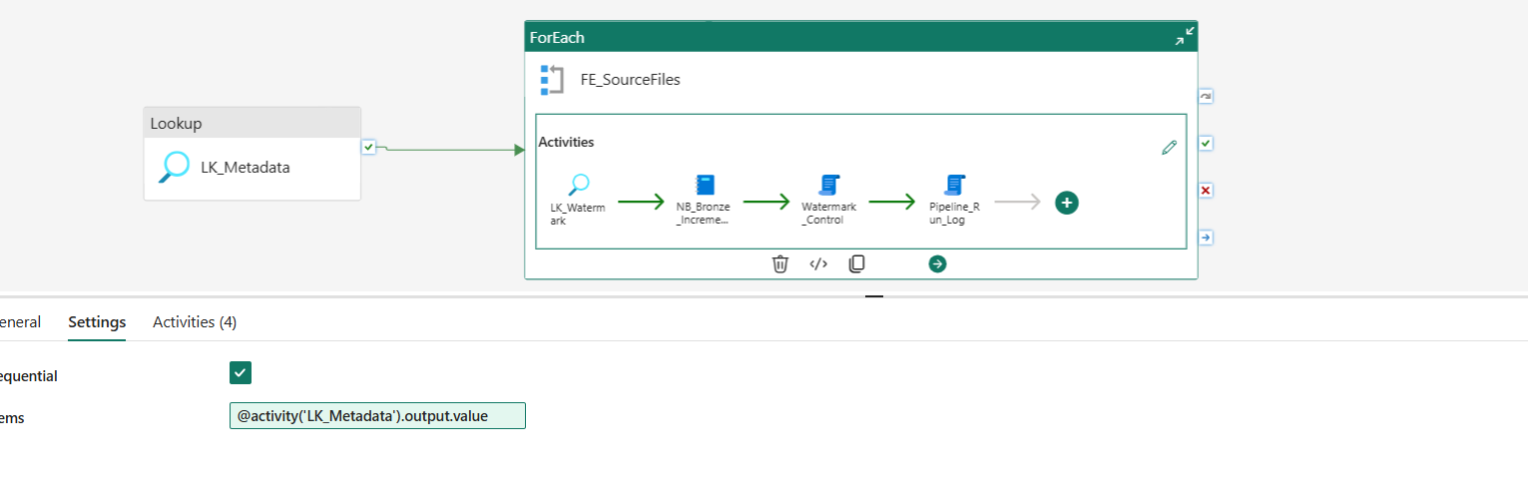
Lk_watermark:
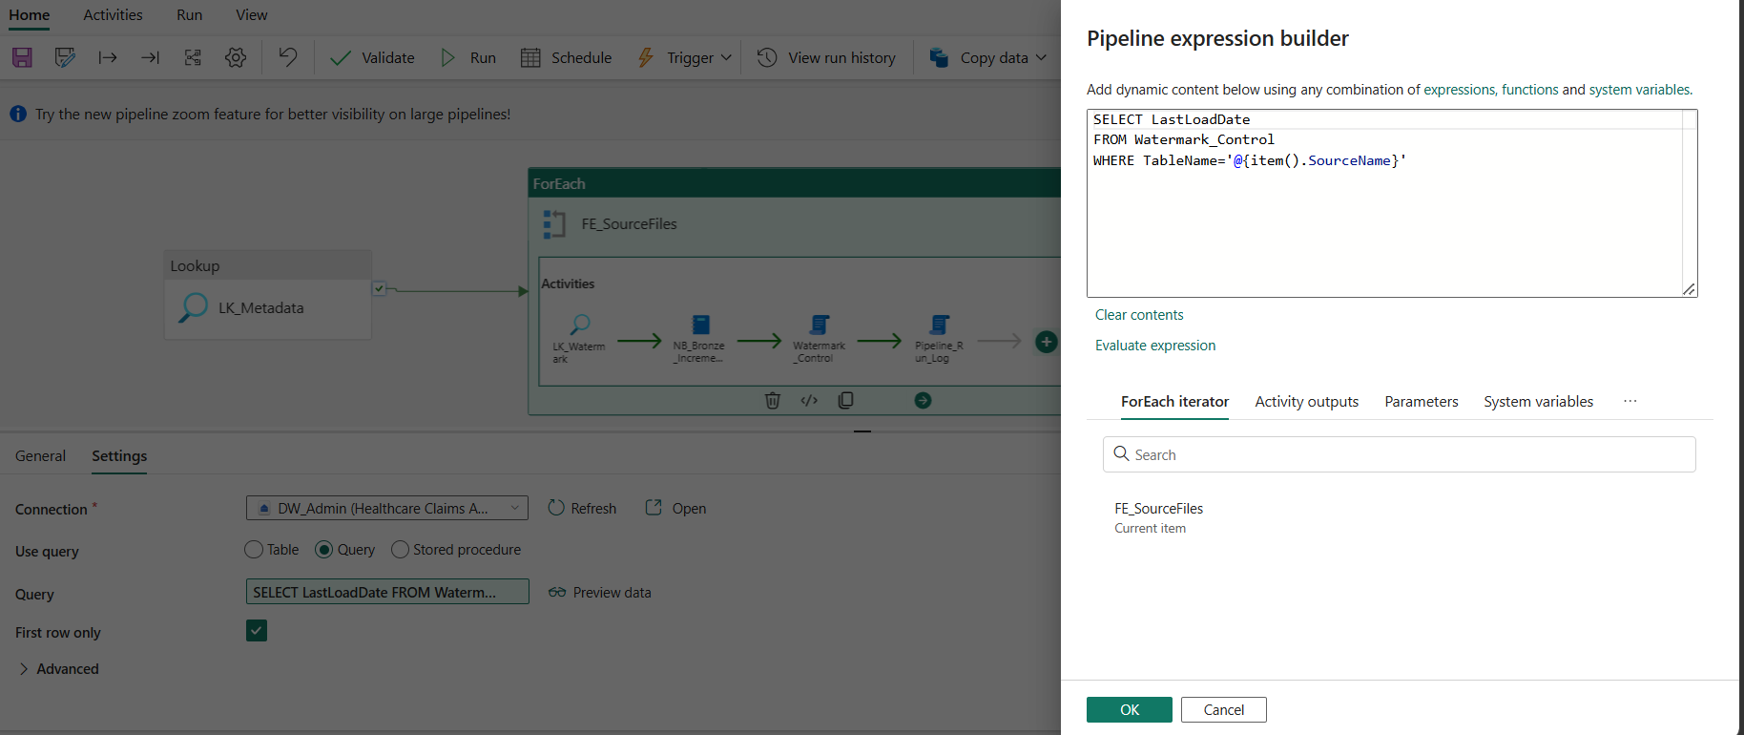
Bronze_notebook:
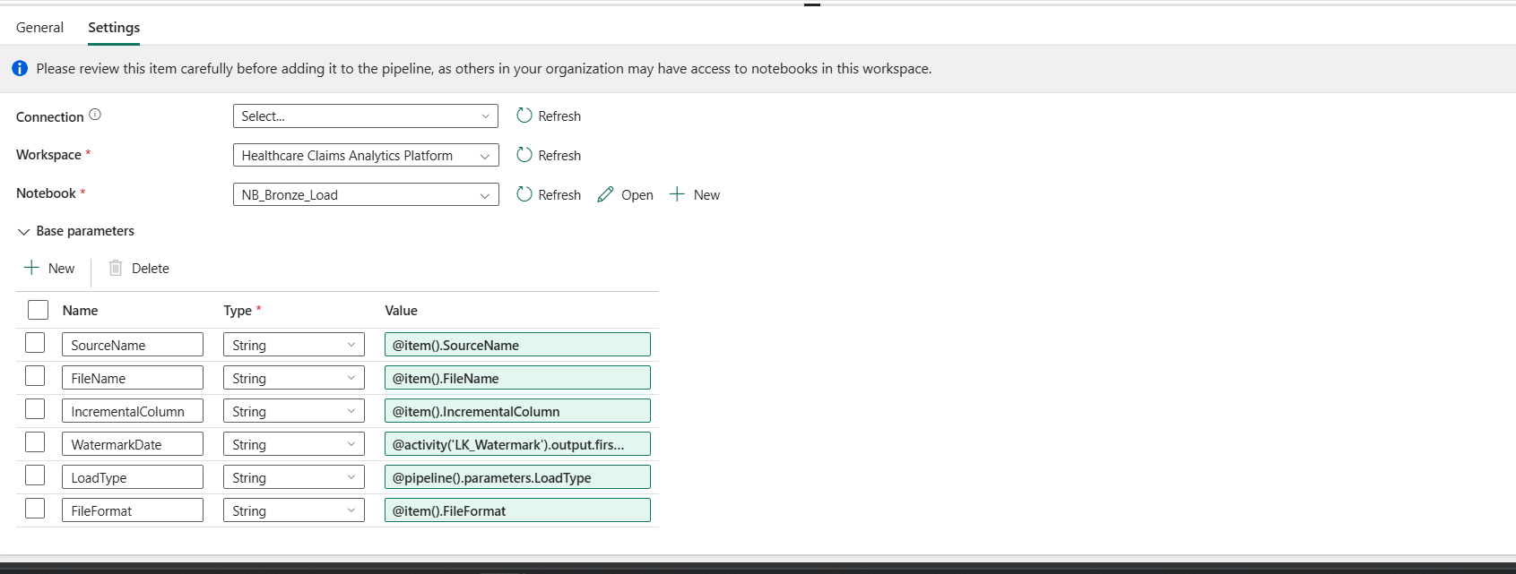
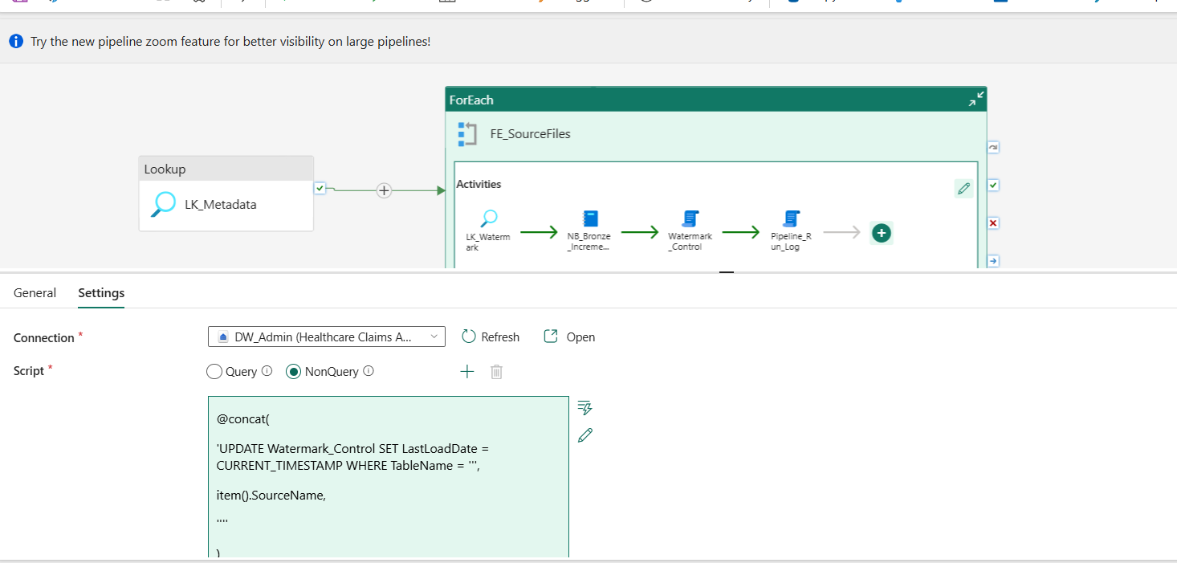
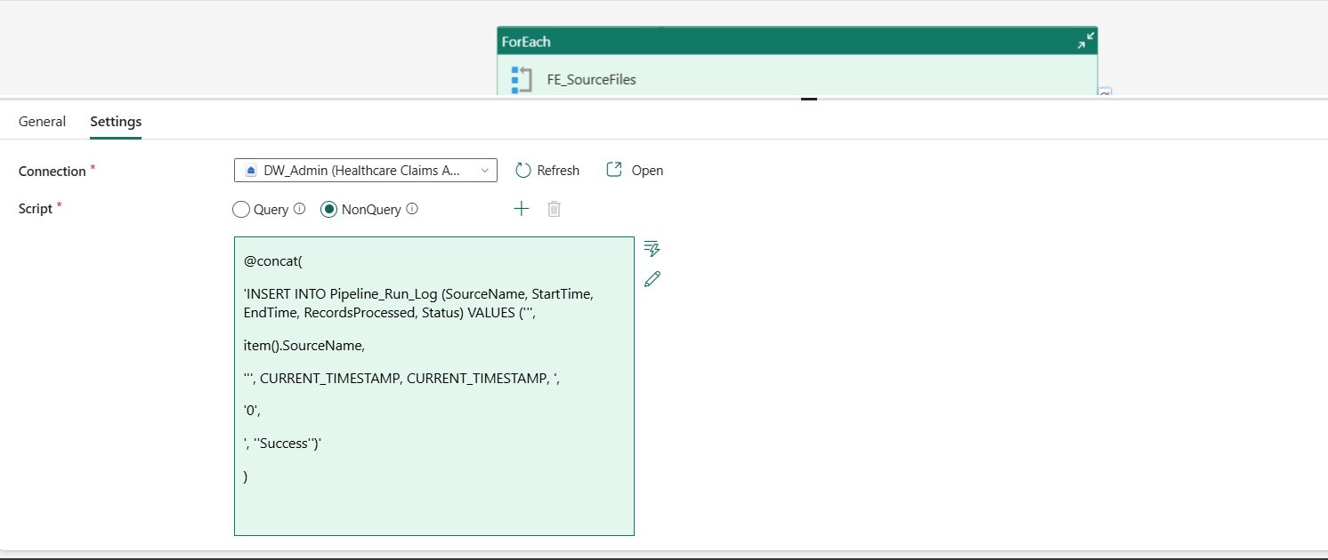

Pl_silver_load:
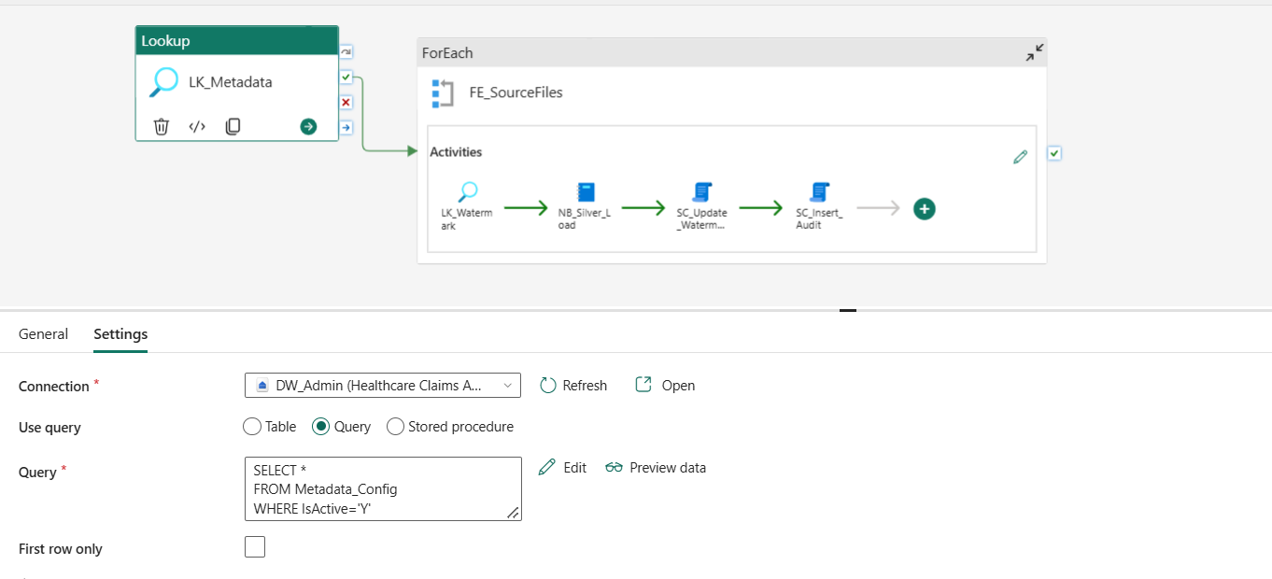
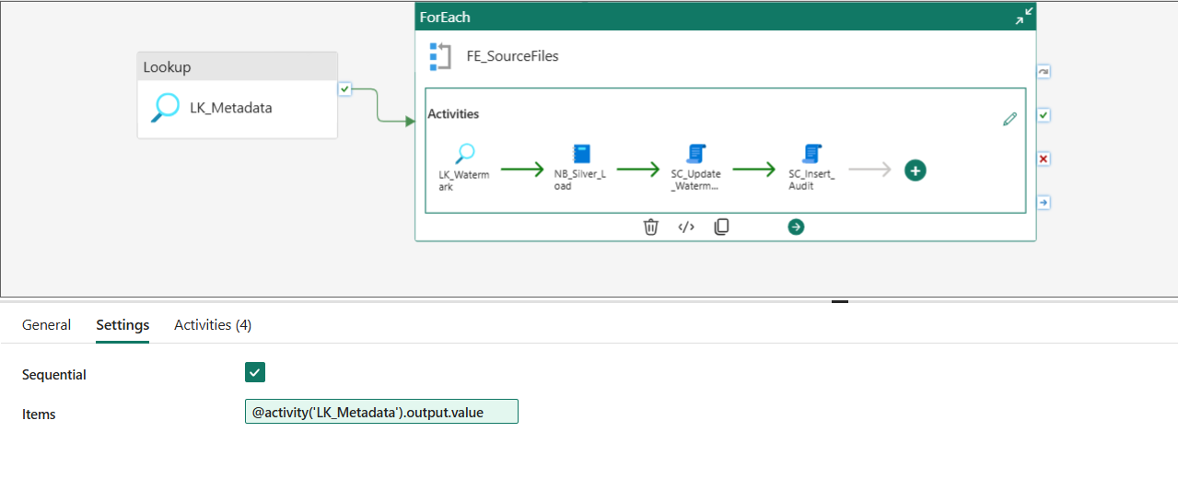
LK_Watermark:
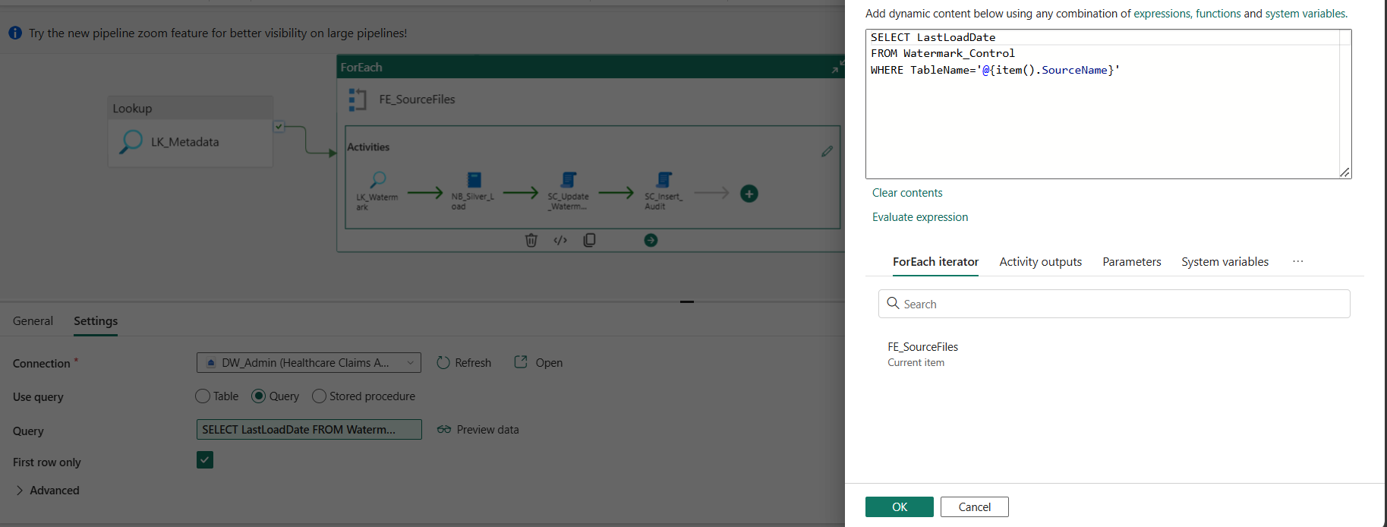
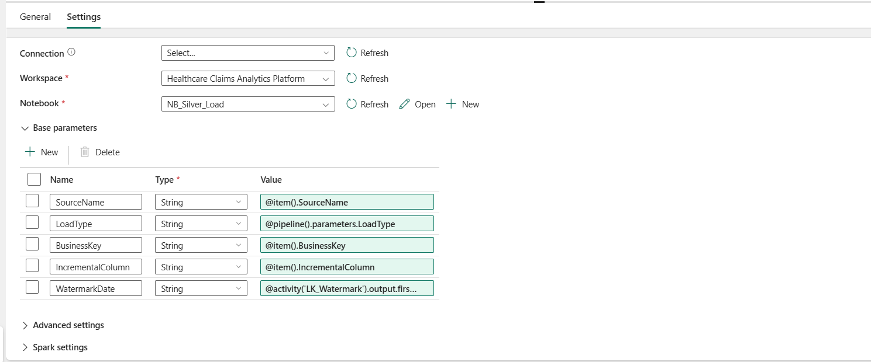
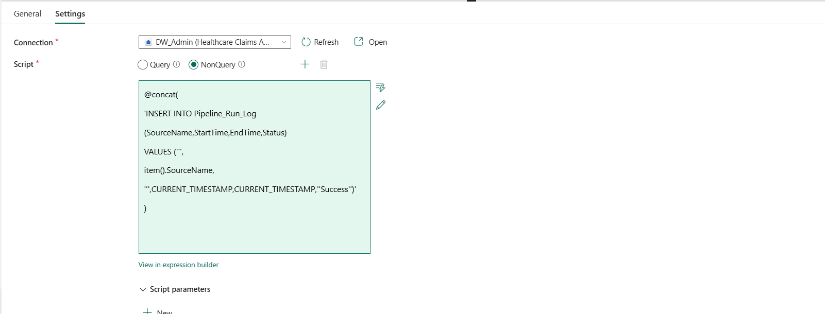

Pl_gold:
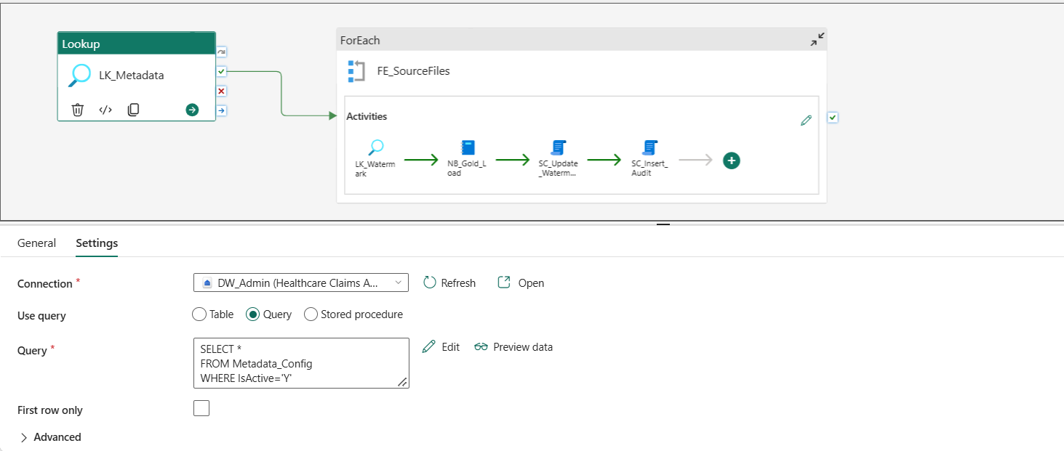
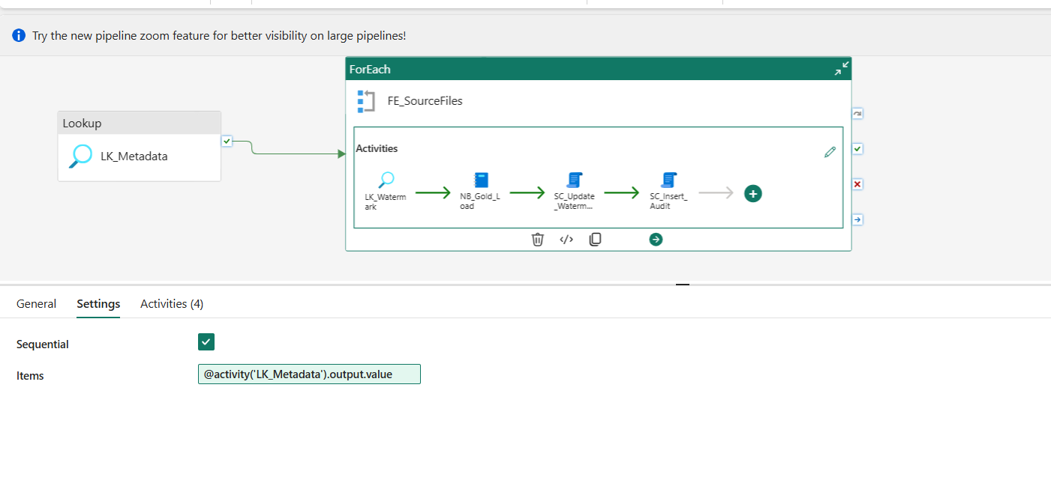
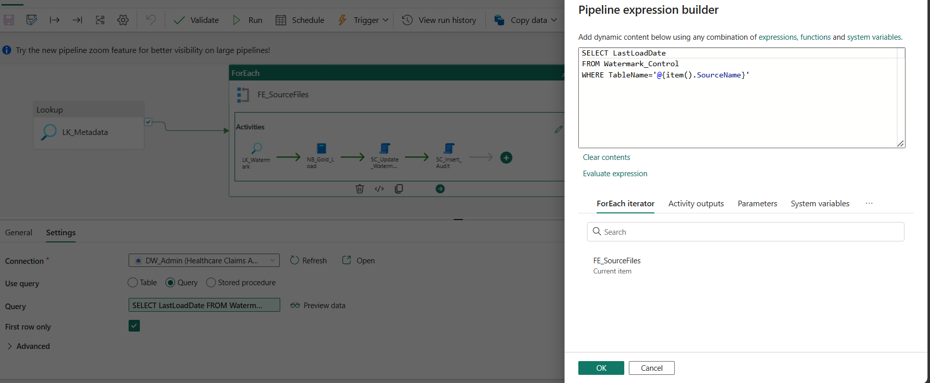

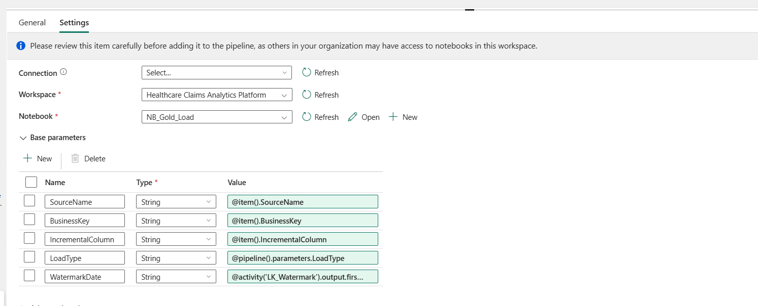
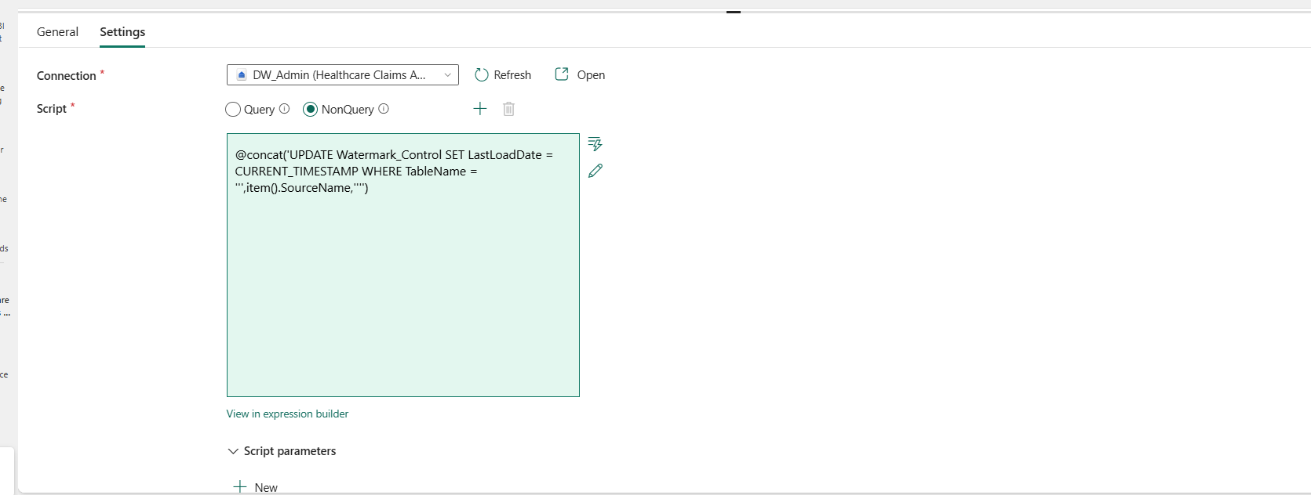
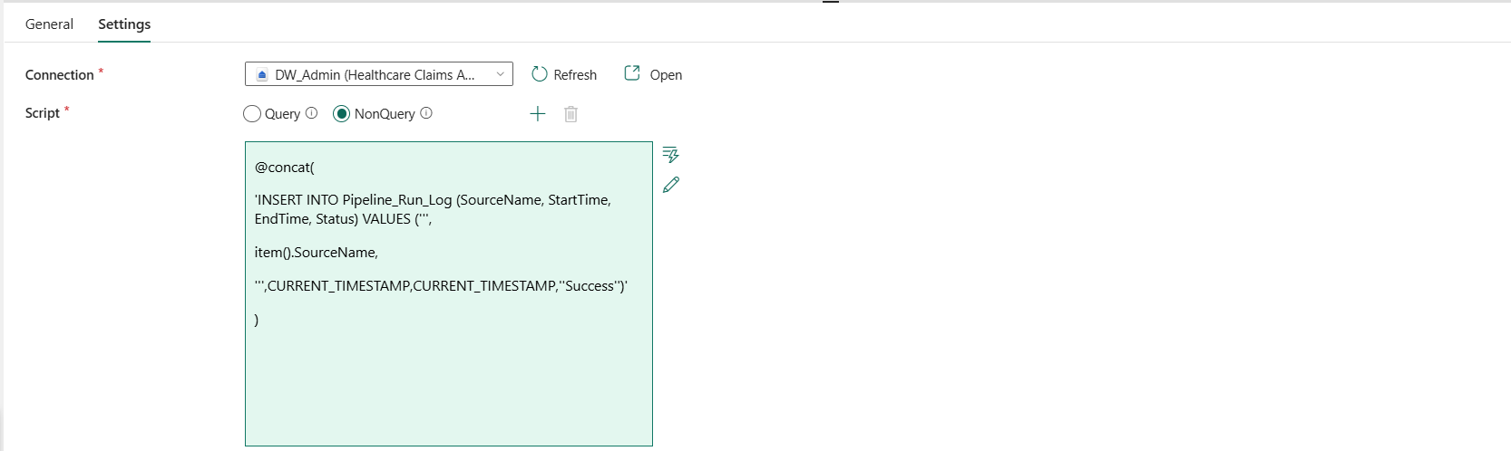
Main _pipeline_orchestartion:
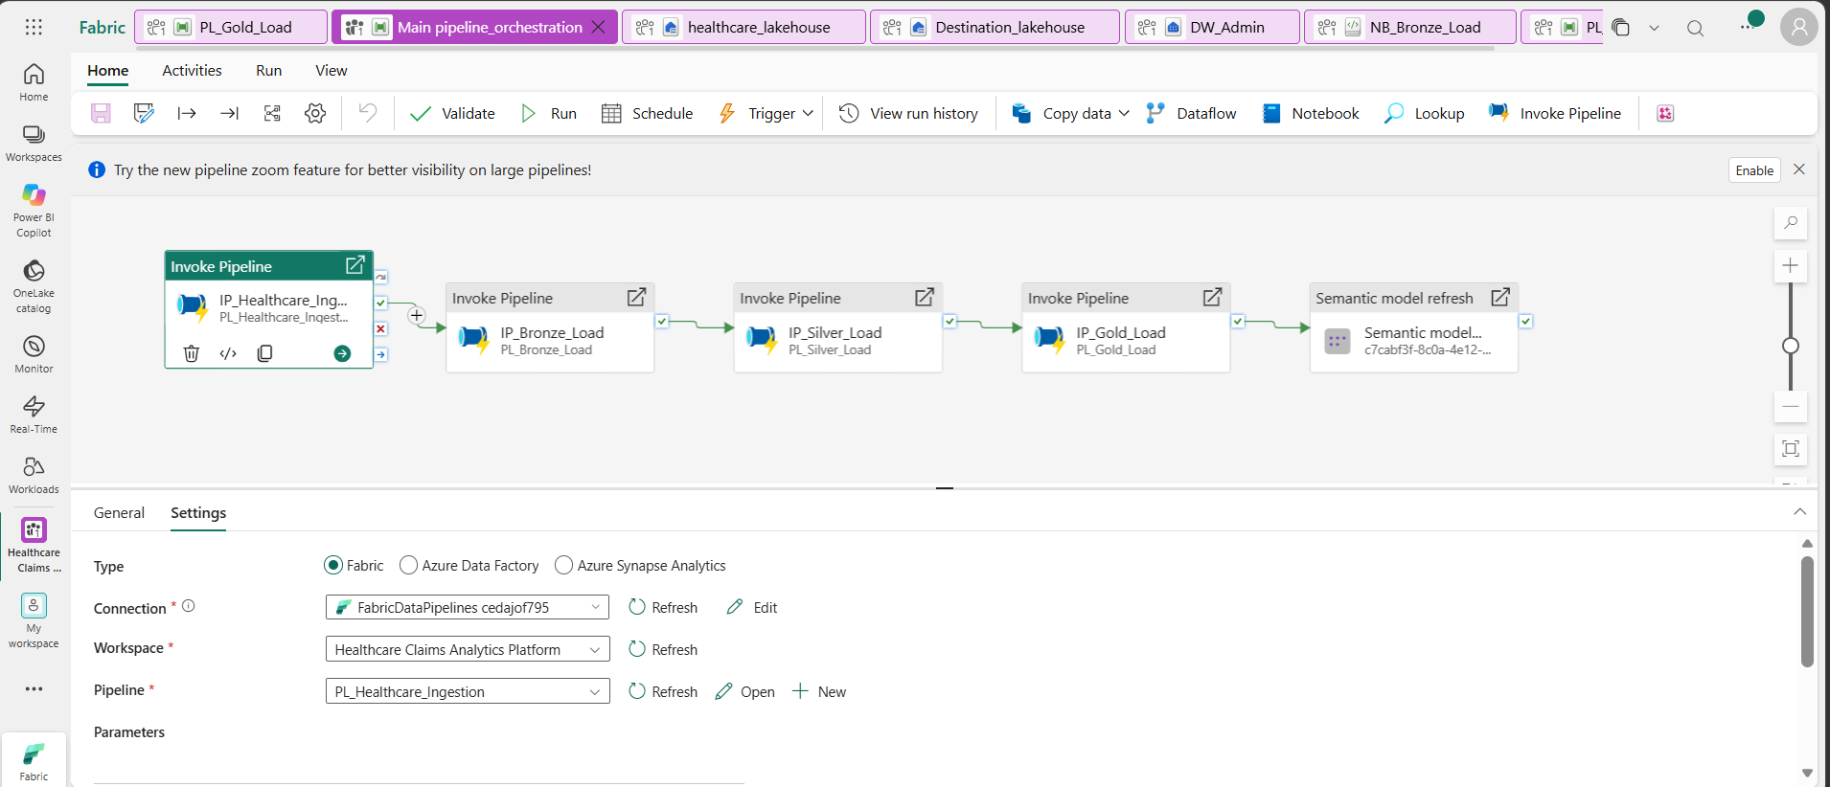
Destination outputs:
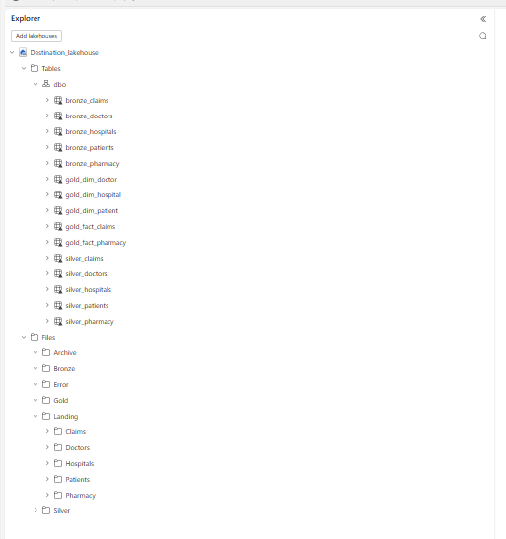
Monitor:
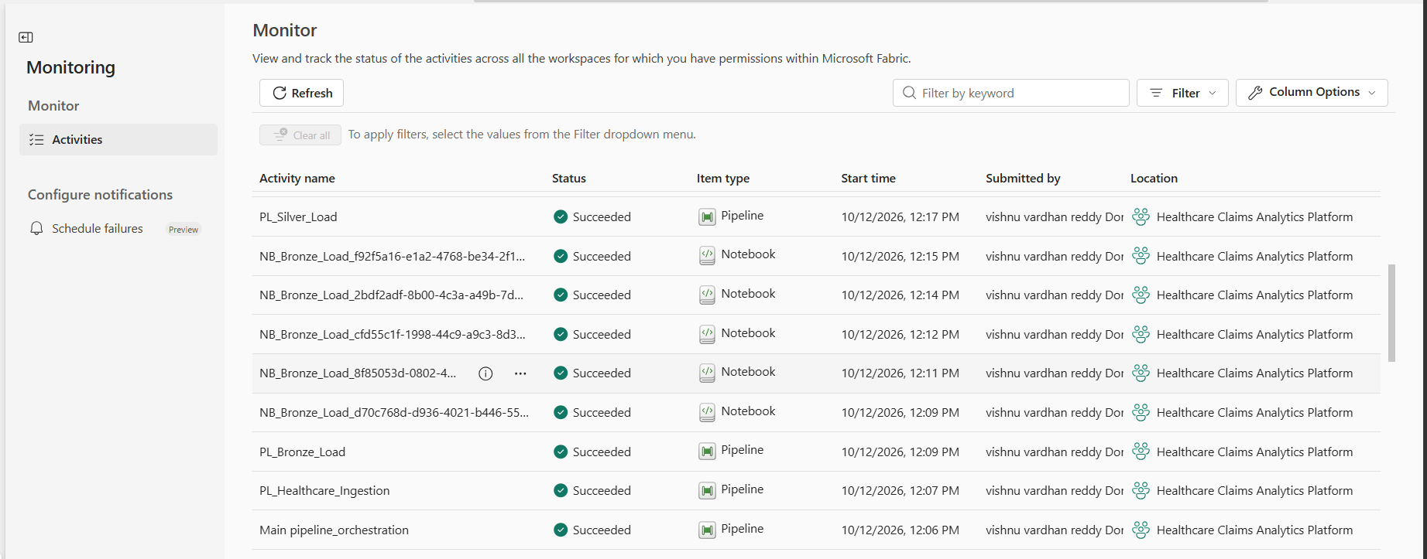
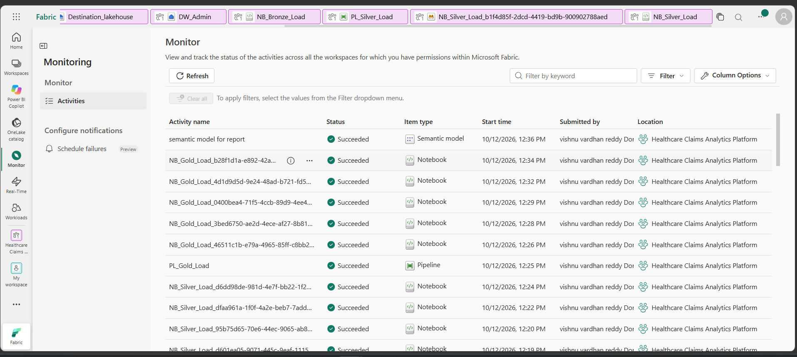
Semantic model:
